***Connecting with the steel supply chain on the safety and structural integrity of hot-dip galvanized fasteners***

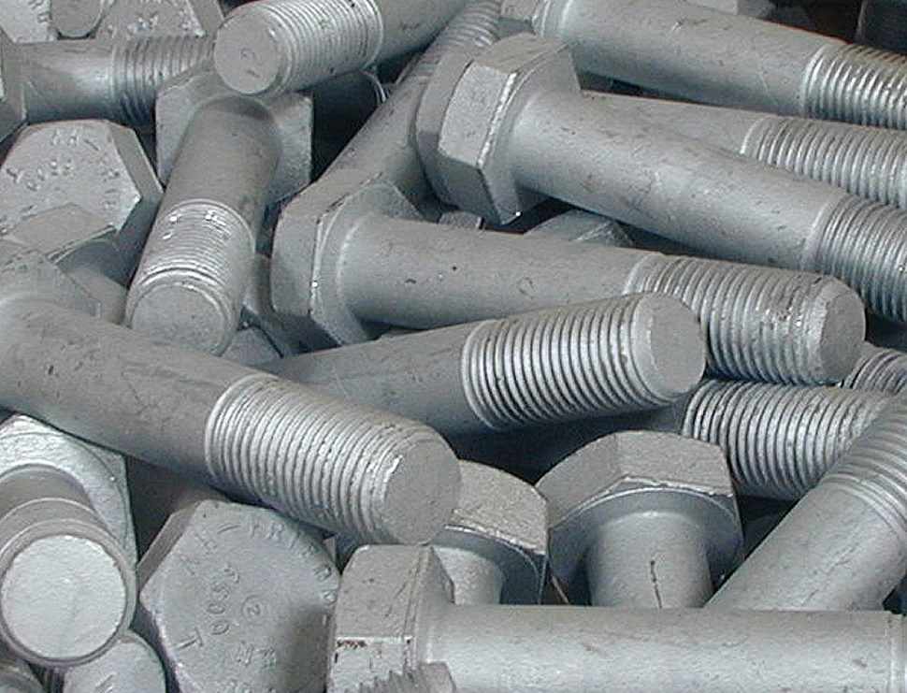Hot dip galvanizing, a tried and tested technology which provides cathodic corrosion protection, ensures safety and structural integrity when applied to fasteners. Although South Africa has the capability and capacity to manufacture these, volumes remain small. A clearer understanding of the benefits of hot-dip galvanizing fasteners – as well as the knowledge of and adherence to stringent industry standards - could grow the market and benefit the entire supply chain, says Robin Clarke, Executive Director of the Hot Dip Galvanizers Association of Southern Africa (HDGASA).

**The nuts and bolts of hot dip galvanising**

The conventional method of hot dip galvanizing – jigging components onto a flight bar and dipping them into molten zinc – is not feasible for small fasteners. Instead, they are placed in perforated baskets for hot dip galvanizing, and then transferred to a centrifuge to spin off any unreacted zinc. This leaves a carefully controlled amount of zinc on the fastener with very good definition in the threaded area.

For the hot dip galvanizing of fasteners, the HDGASA supports and promotes adherence to the ISO 10684 and 1461, as well as the SANS 121 (2024) standards. These specify a minimum galvanized coating of 50 microns for threaded articles with a diameter exceeding 6mm; and 25 microns for those with diameters equal to or less than 6mm.

Clarke emphasises that engineers design structures with sufficient strength to perform their functions: “Corrosion control is integral to strength calculations. The use of the correct fasteners, particularly in a structural steel environment or highly corrosive climate, is critical. The considerations applied to corrosion control of nuts and bolts should, at all times, equal those applied to the main structural members.”

**Fastening on to the benefits**

Clarke notes that because hot dip galvanizing provides a thicker coating than zinc plating or electro deposition methods, the service life is significantly longer: “Galvanized fasteners are frequently specified – only to find that these have in fact been zinc-plated. The assumption tends to be that anything zinc-coated is hot dip galvanized. However, a plated fastener has a 10-micron coating - which is 2.5 - 5 times below the specified standard for hot- dip galvanized fasteners.”

He also warns against using stainless steel fasteners to join galvanized steel structures: “This mismatch of materials creates a galvanic corrosion cell which accelerates corrosion of the hot- dip galvanized articles. They sacrifice themselves to protect the stainless steel nuts and bolts. The hot dip galvanized steel retreats from the stainless steel, giving the impression that it has failed.”

Price and aesthetics are also challenges, with the thin coating on a painted article appearing more attractive - and more cost-effective. Clarke concedes that, with South African construction supply chains under pressure, there is always a temptation to resort to cheaper options - which are often imports – without sufficiently considering how these will perform from a safety and quality perspective.

**Connecting over challenges**

Furthermore, Clarke points out that concerns surrounding hot dip galvanizing of high tensile nuts and bolts which exceed a 10,000 mega pascal tensile strength rating are unfounded: “While it is believed that these are prone to hydrogen embrittlement and should not be hot dip galvanized, German companies are hot dip galvanizing tensile fasteners at volume. This is done by mechanically cleaning fasteners prior to hyper-galvanizing and flash pickling them, to minimize the potential for hydrogen ingress into the fastener,” he explains.

Clarke also mentions that correct storage and handling of hot-dip galvanized fasteners is imperative. These should be stored and delivered to site with the nut secured onto the bolt: “The torqueing of hot-dip galvanized fasteners is usually done by the ‘turn of the nut’ method. A manufacturer will specify a fixed torque to which a metal bolt should be tightened. However, because the threads of hot-dip galvanized fasteners are coated, it is very difficult to do this. So, the method of fastening is to turn the nuts to achieve a snug fit. Once that is done, the nut is then turned (depending on the size and length of the nut and the bolt) by a further third to full turn.

Correctly hot-dip galvanized fasteners play an integral role in the ‘nuts and bolts’ of enduring, successful steel construction. The HDGASA is committed to working with our members - and the wider steel supply chain - to ensure the quality and standards of hot-dip galvanized fasteners, through the provision of guidance, technical education and advisory services,” Clarke concludes.