***The HDGASA galvanizes micro-enterprises to learn and grow with its ‘open door’ approach***

**Educating and equipping micro-enterprises – small businesses - to embrace hot dip galvanizing, the widely preferred method of corrosion control for steel.**

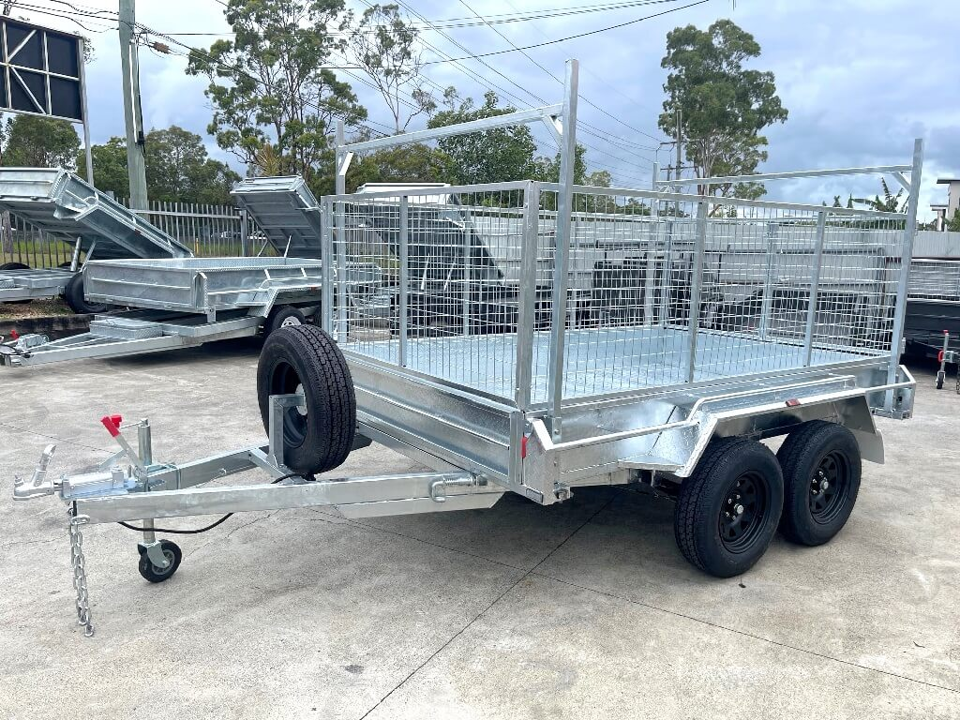“A great oak tree does not grow overnight. As an industry, we must remember that the great oaks of tomorrow are just saplings today,” says HDGASA Marketing Manager, Anthony Botha.

“In South Africa, youth unemployment is currently sitting at approximately 60%. Government is looking at youth training programmes such as welding and metalworking. People will use these skills for their own entrepreneurial pursuits. Others may have already developed skills in fabrication or manufacturing, and are now trying to set up their own businesses. Despite having had some exposure, they may not yet fully understand the technology,” Botha points out.

The HDGASA provides technical support to micro-enterprises online via the Association’s website and responds to phone and email enquiries - providing what Botha calls “ground-level entry to education on galvanizing” for the entrepreneur who may be working out of his home garage or a small factory unit.

Guidelines can be easily downloaded and are written not only for technically qualified people such as engineers, but for non-technical entrepreneurs, who are looking for practical information and advice about hot dip galvanizing as a means of corrosion control.

**Supply and demand**

In certain parts of the country where corrosion is high, there is already significant demand for galvanizing - even from small businesses or semi-professional DIY businesses making steel articles such as gates, burglar proofing, fencing or trailers.

“However, to optimise the protection provided by galvanizing, micro-entrepreneurs must understand their role: for example, inserting venting and drainage holes, as well as other technical requirements,” Botha points out.

He adds that micro-enterprises should understand that hot dip galvanizing is a final phase in the downstream supply of steel products. It is therefore a finishing, rather than an applied coating: “It is not paint, or something that you can take and put on yourself. There are some misconceptions around what the market perceives as ‘cold’ galvanizing. This refers to a zinc-rich paint, applied to very small items in non-aggressive environments. With hot dip galvanizing, an item is dipped into a kettle of molten zinc at 450°C. There is a significant difference in the outcome.”

**A two-pronged approach to protection**

Botha notes that the end-user also requires education: “The person bringing in the work is not necessarily the one who gets to use the product. So the galvanized gate, the boat anchor; the burglar proofing or fencing is used by another party. This is about protecting both the business owner and their customers. It is a two-pronged approach.”

He stresses that the quality of galvanizing is driven by the steel itself. Once an article has been made, the dye is cast and there is very little that a galvanizer can do.

Different types of steel have a different chemical composition, which reacts with the zinc to give it a certain appearance. This varies from bright, shiny, silvery galvanizing to a dull grey. Corrosion control is the primary focus - with aesthetics being a secondary consideration.

Paint can be applied to galvanized steel - but again, the right choice of paint and preparation is essential: “We supply a lot of information on our website about how to prepare galvanizing for a paint coating. Once again, it comes to communicating, coordinating and cooperating around the galvanizing of an item.”

Botha says it is important for the small business to ask the big questions and to **“**be its own policeman” when it comes to quality control: “Small businesses should not only understand what they are dealing with - but should use the resources at their disposal, including the Hot Dip Galvanizing Association and the galvanizer.

For example, before buying steel, the small business should ask the galvanizer for their recommendations and referrals to reputable steel merchants, and request certificates for any steel that is bought.”

**Ambassadors for galvanizing**

“We would really like to see the education, training and advisory requirements of micro-enterprises more adequately catered to by established industry,” Botha emphasises.

The good news on the galvanizing front is that this is already happening, with galvanizers that are members of the HDGASA setting up remote depots specifically to accommodate the needs of micro-enterprises.

Many HDGASA member galvanizers provide for depots in remote areas where articles for galvanizing can be dropped off and collected. Access to galvanizing is therefore closer than if it was only available at the galvanizers’ main facilities,” he explains.

“A strong relationship with a galvanizer gives the micro-entrepreneur opportunities over time. For example, the better the relationship, the better the quality of the products coming in, the welding and the preparation for hot dip galvanizing. Ultimately, this is about growing both businesses. The solo micro-entrepreneur who starts out making one gate, could be making 20 by the end of the year,” concludes Botha

***Ends***

***(843 words)***

**Note to Editors:**

The Hot Dip Galvanizers Association Southern Africa (HDGASA) is a not-for-profit trade association dedicated to serving the needs of the entire industry supply chain – from end-users, specifiers, architects and engineers to contractors, fabricators and hot dip galvanising shops across Southern Africa.

Founded in 1965, the Association’s primary objective is to develop and expand the market for hot dip galvanizing and duplex systems as a cost-effective corrosion control technologies. It is dedicated to both identifying and leveraging opportunities for the provision of services on behalf of its members.

Over the years, the HDGASA has evolved to the point where it plays multiple roles, acting not only as a voice and lobbyist for the industry but also as a hub of technical knowledge, advice and support.

It provides training and information to end users, engineers, consultants, contractors, end-users, specifiers, designers and architects by way of courses, presentations, technical research papers, plant tours and via advisory involvement at the design stage of projects. In addition, the HDGASA works closely with regulatory and standards authorities setting quality standards that impact on the corrosion control and associated industries.

**Editorial Contact**

Kendal Hunt

Managing Director

Kendal Hunt Communications PR and Media Liaison Agency

+27 - 11 462 6188

+27 - 82 823 6533

[kendal@kendalhunt.co.za](mailto:kendal@kendalhunt.co.za)